A Bayesian Framework for Synthetic Fraud Detection: Combining Behavioral and Financial Signals

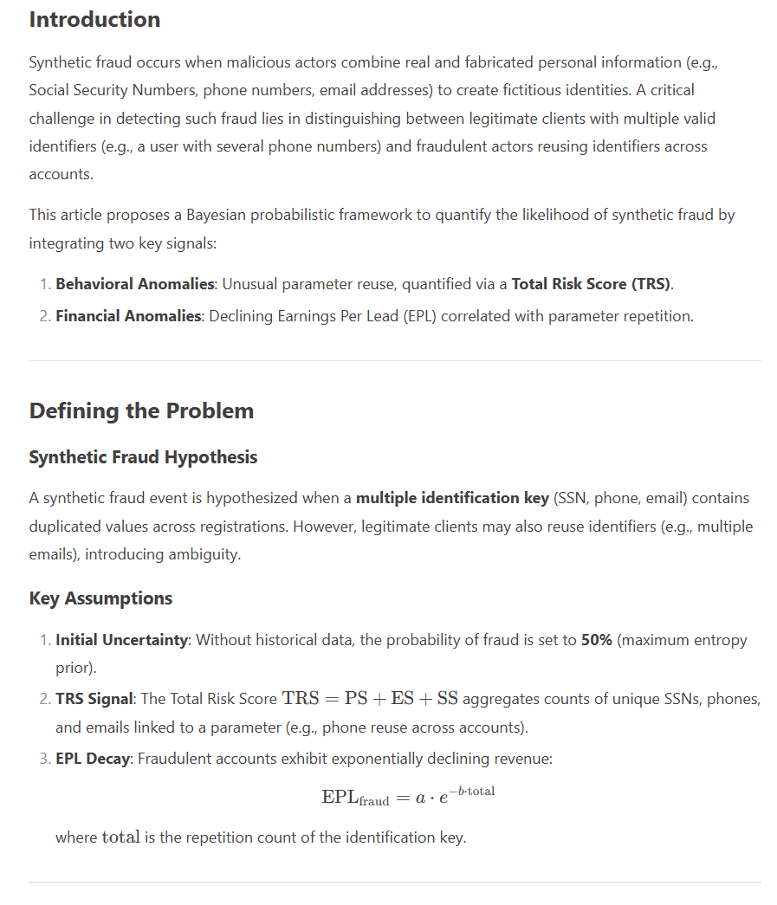
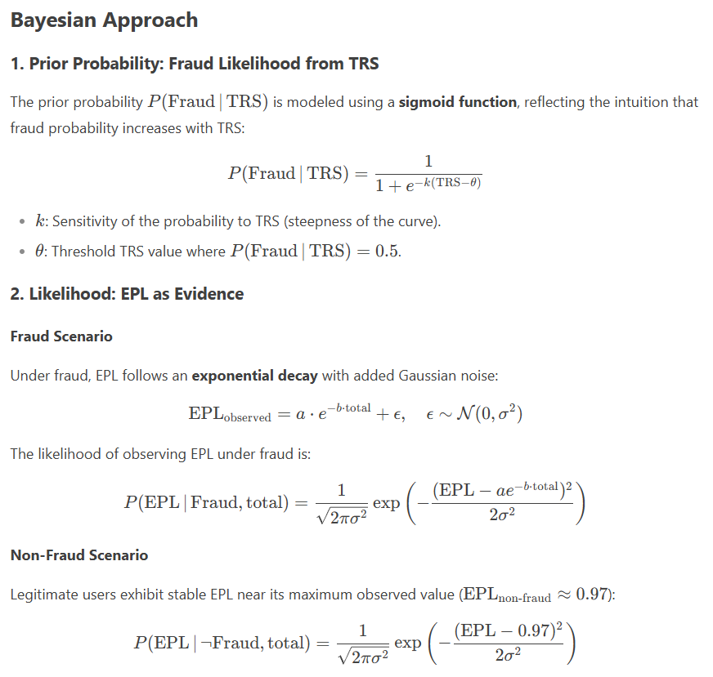

3. Posterior Probability
Using Bayes’ theorem, the posterior probability of fraud is:
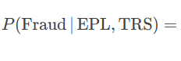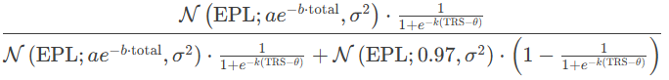

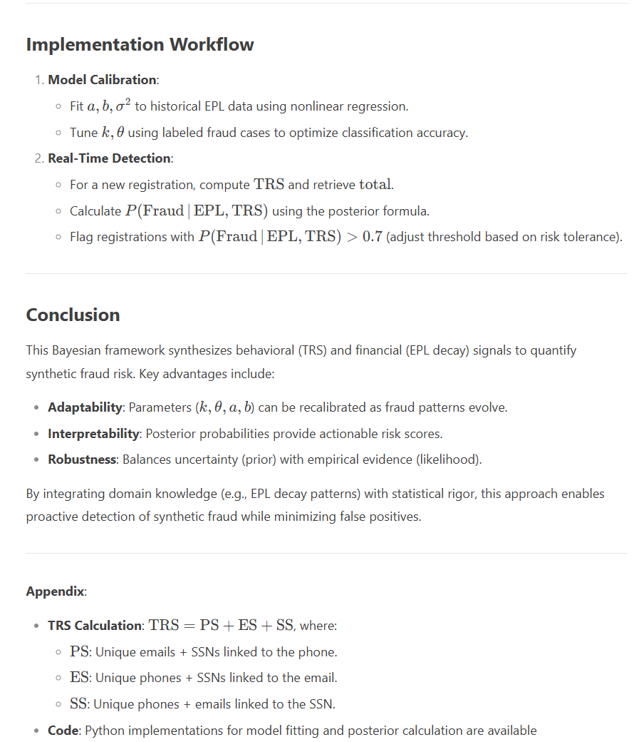

The fraud detection model has been implemented in Python, and the posterior probability of fraud based on EPL values is visualized in the plot below.

